Third Party warehouse to Mother warehouse Spares return Process

1. Login

User: Third party warehouse logistics coordinator

Type the URL : https://delups-in-uat.mservice.net/

Enter the Login credentials and do the login

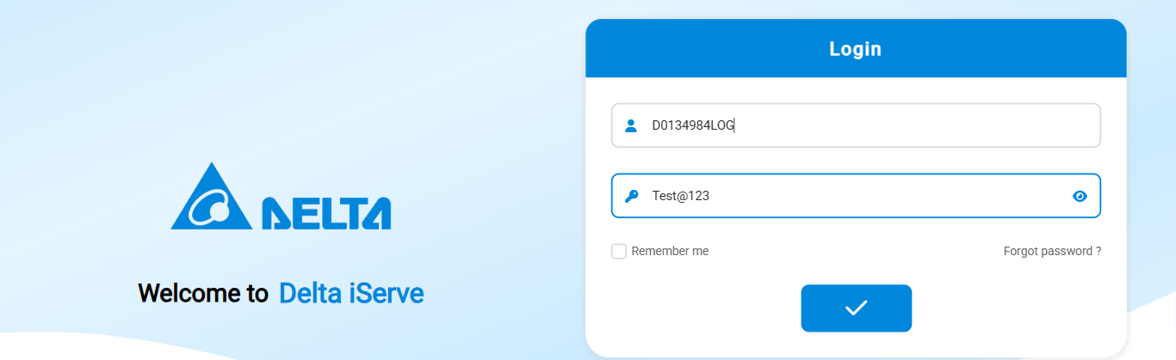2) Go to Inventory Module click inventory Issue

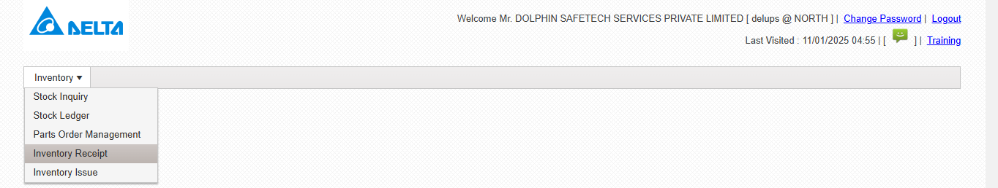3) Click add symbol then the below screen will appear. Enter the details, select the supplier code from the dropdown according to the selection the spares list will appear.

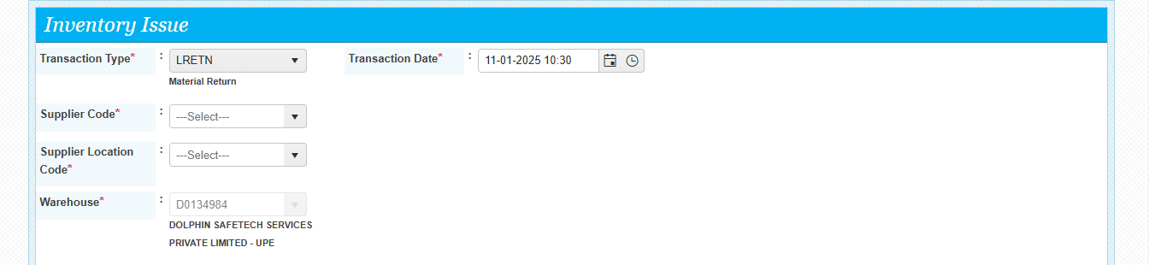

Confidential to Selfservit & Delta Electronics

Third Party warehouse to Mother warehouse Spares return Process

Select the supplier code and click on excel import

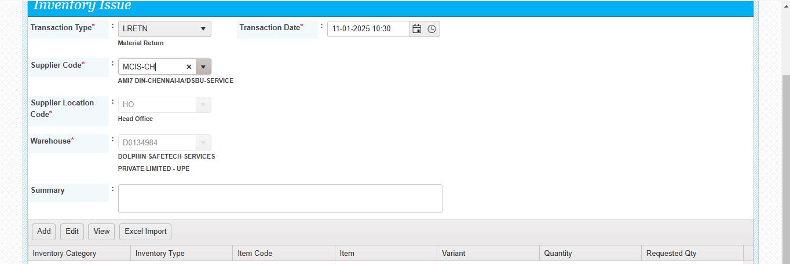The below screen will appear. Return type dropdown is provided here. Select the type. According to the selection the spares will be listed in the screen,

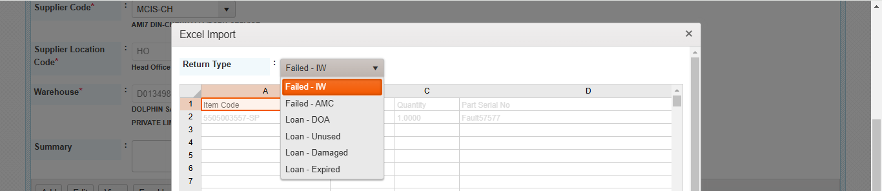Failed IW selected, according to the selection system filled the material in the excel.

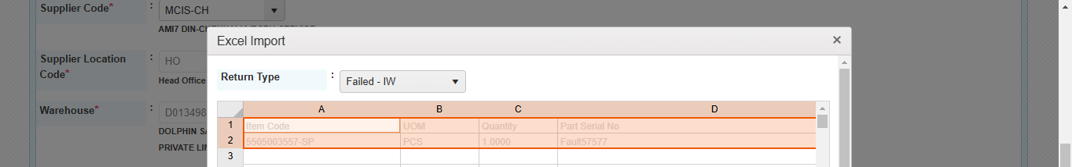Click submit. Now the screen will show the items to be returned, click submit, 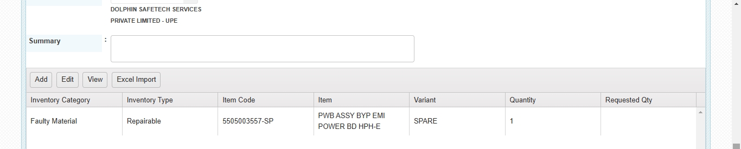Confidential to Selfservit & Delta Electronics

Third Party warehouse to Mother Warehouse Spares return Process

Now the issue is generated. Now the status of the issue is Awaiting for OEM SO DO. Assigned to the regional parts coordinator.

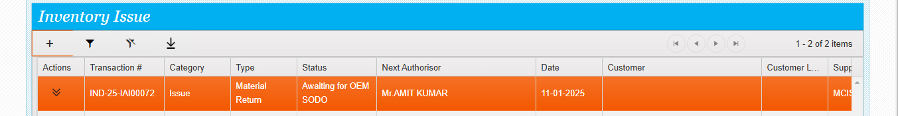

User: Regional Parts coordinator

DO the login

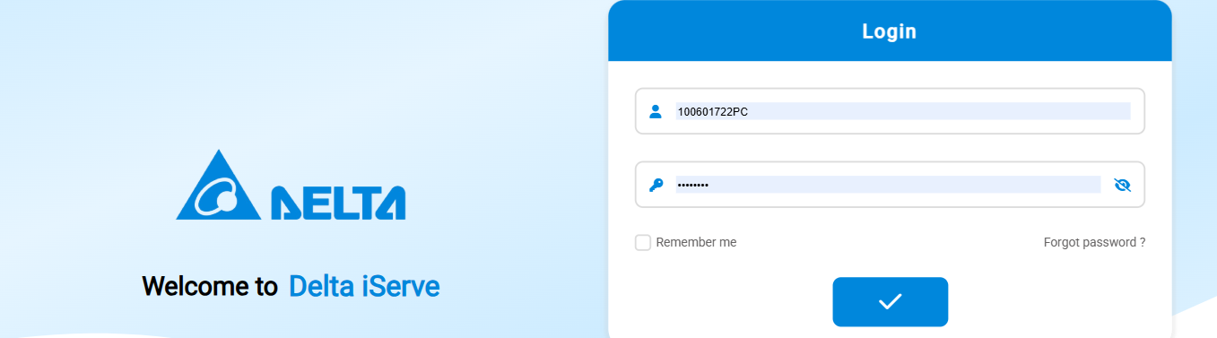Go to inventory issue and see the issue assigned for RETURN SO DO.

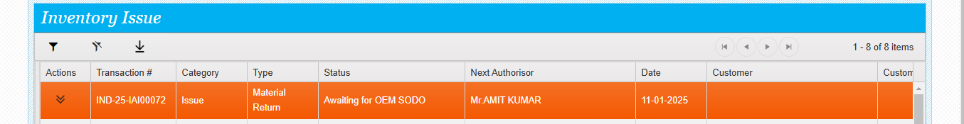Click on actions and do RETURN SO DO UPDATE

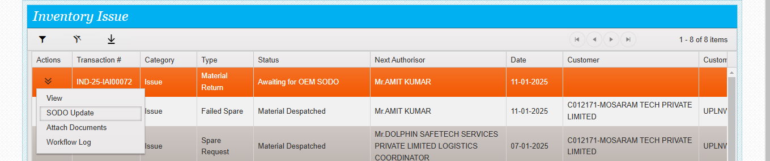

Confidential to Selfservit & Delta Electronics

Third Party warehouse to Mother Warehouse Spares return Process

The below screen will appear

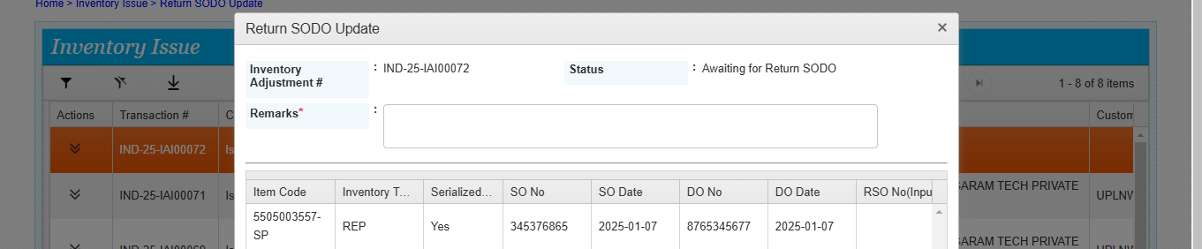Enter the return so do no and submit

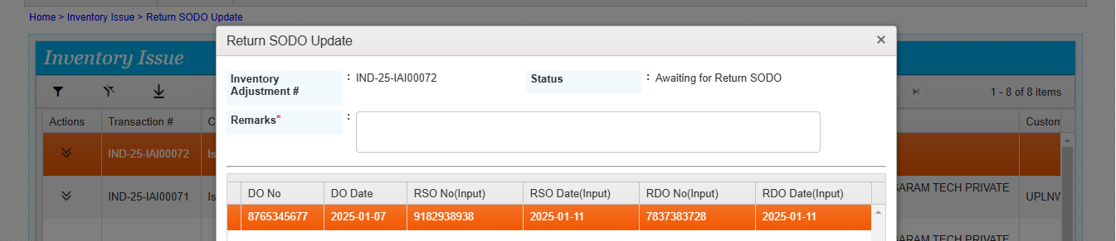Return SO DO done successfully.

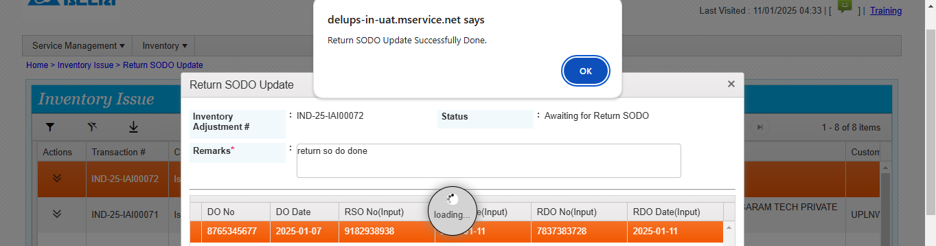Now system assigned the issue to the third-party warehouse coordinator for the logistics update.

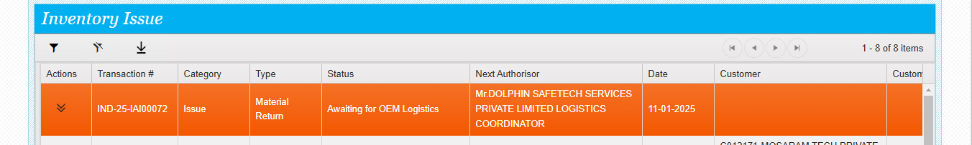

Confidential to Selfservit & Delta Electronics

Third Party warehouse to Mother Warehouse Spares return Process

User: Third party logistics coordinator

Do the login

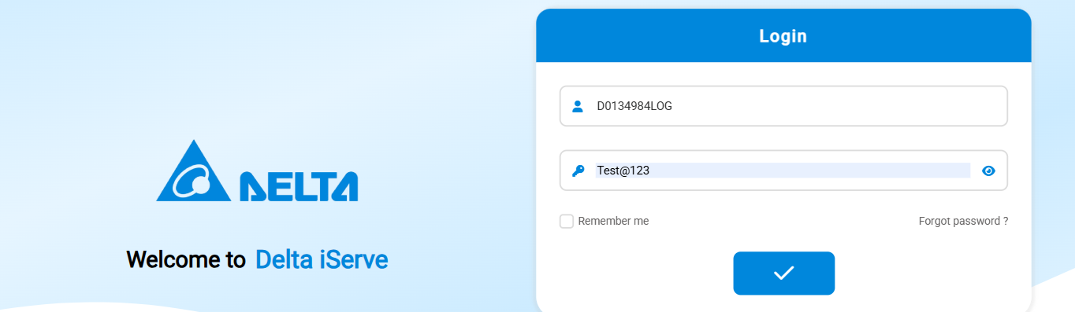2) Go to Inventory module, inventory issue and see the return issue assigned to Third party logistics coordinator for the logistics update.

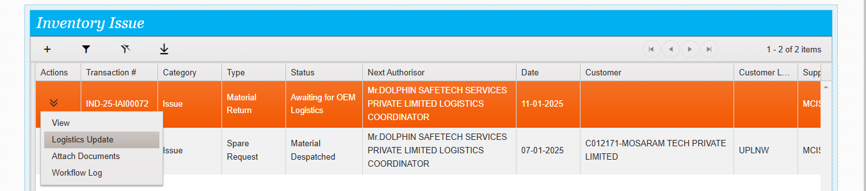3) Click actions and see the actions available, click logistics update and see the screen below.

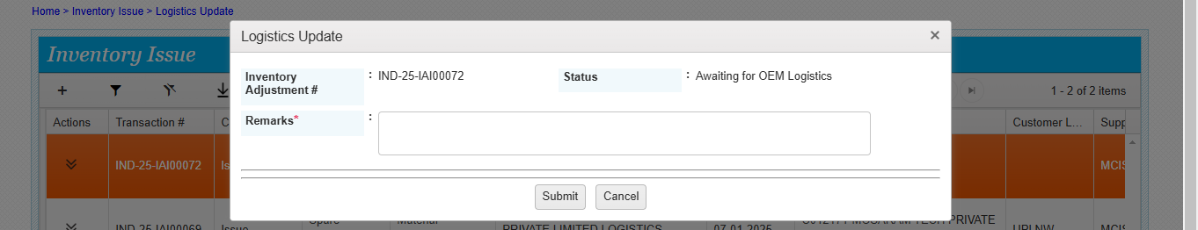

Confidential to Selfservit & Delta Electronics

Third Party warehouse to Mother Warehouse Spares return Process

4) Logistics update done successfully.

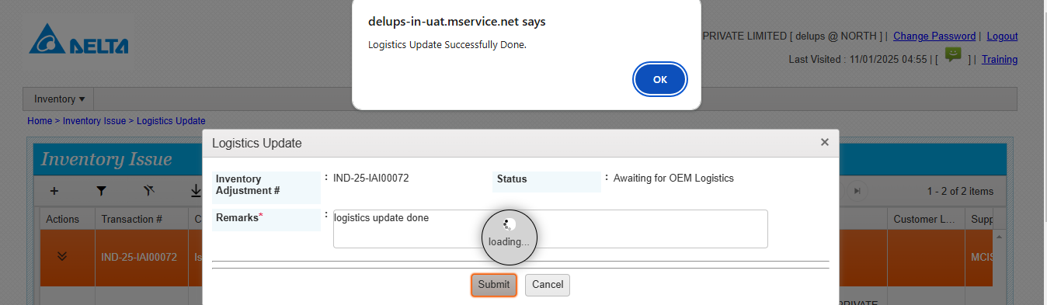5) Now the issue status is awaiting for pick pack update

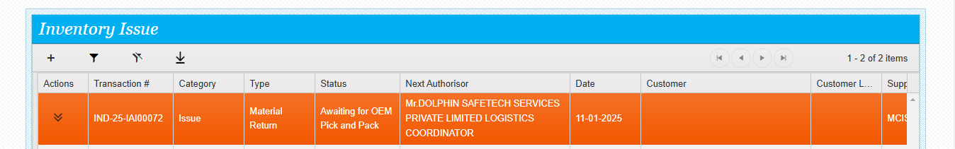6) Click actions and see the action available

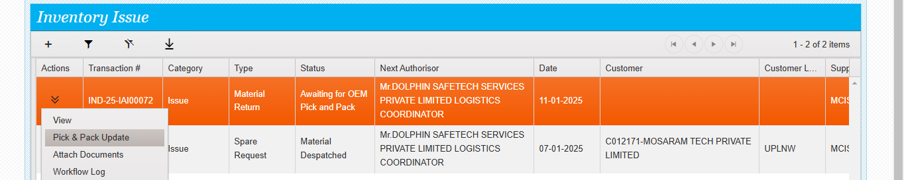7) Click on pick pack update. Below screen will appear. Enter the comments and no of packages

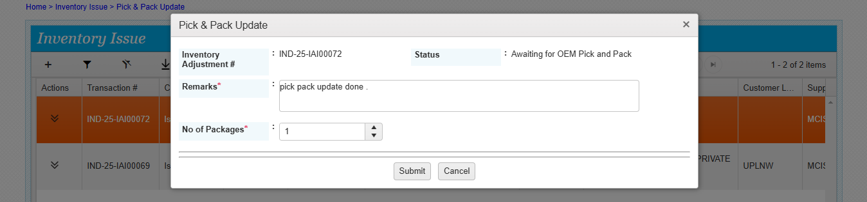

Confidential to Selfservit & Delta Electronics

Third Party warehouse to Mother Warehouse Spares return Process

8) pick pack update done successfully.

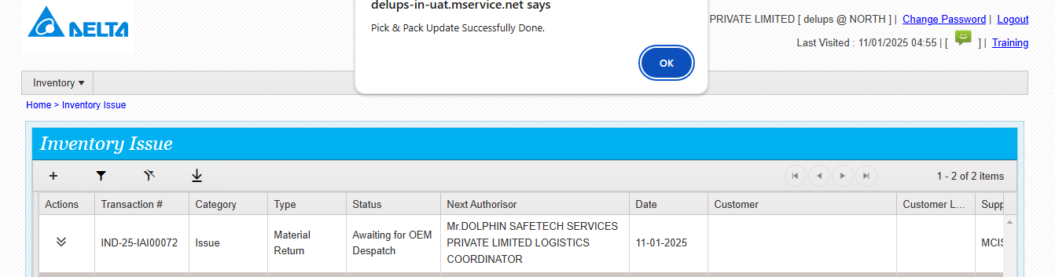9) Now the status is Awaiting for despatch update

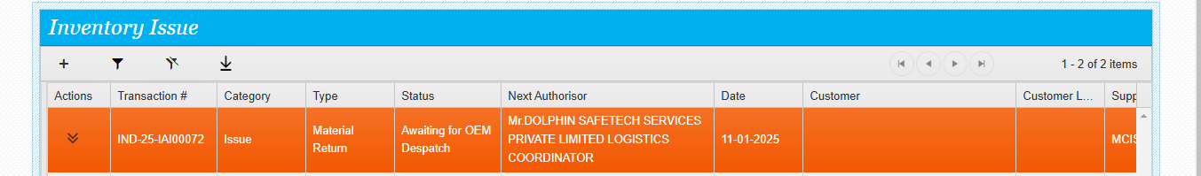10) Click actions and see the next action despatch update

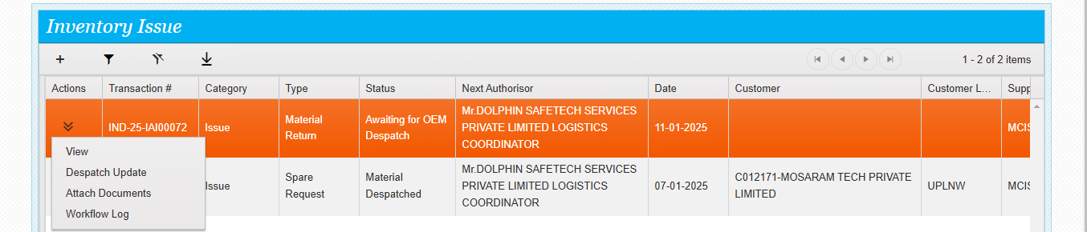

Confidential to Selfservit & Delta Electronics

Third Party warehouse to Mother Warehouse Spares return Process

11) The below screen will appear to do the despatch update

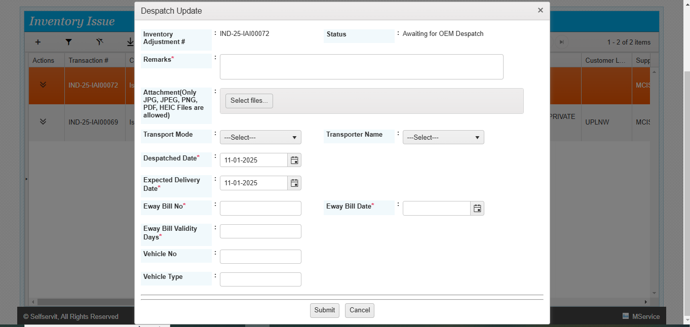12) Fill in all the details and submit.

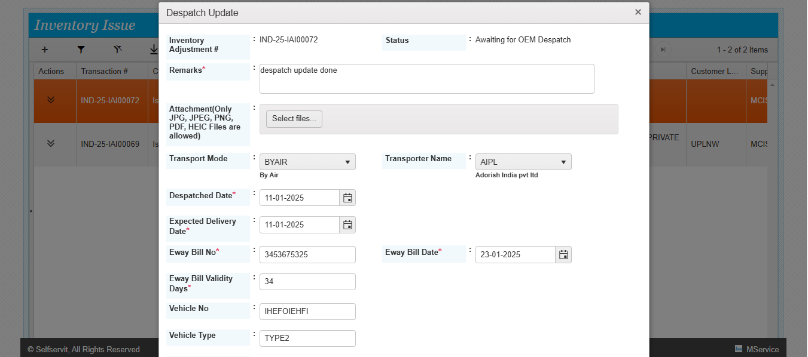

Confidential to Selfservit & Delta Electronics

Third Party warehouse to Mother Warehouse Spares return Process

13) Despatch update done successfully.

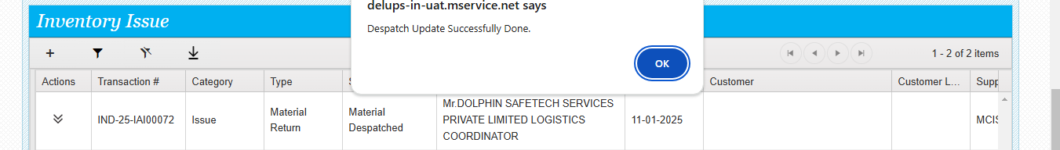14) System generates a receipt against this despatch and assigned to the respective Mother warehouse to do the GRN

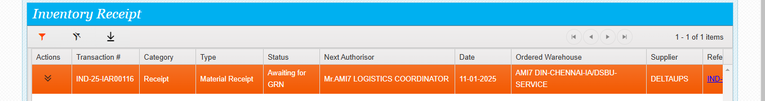User: Mother warehouse logistics coordinator

1. Do the Login

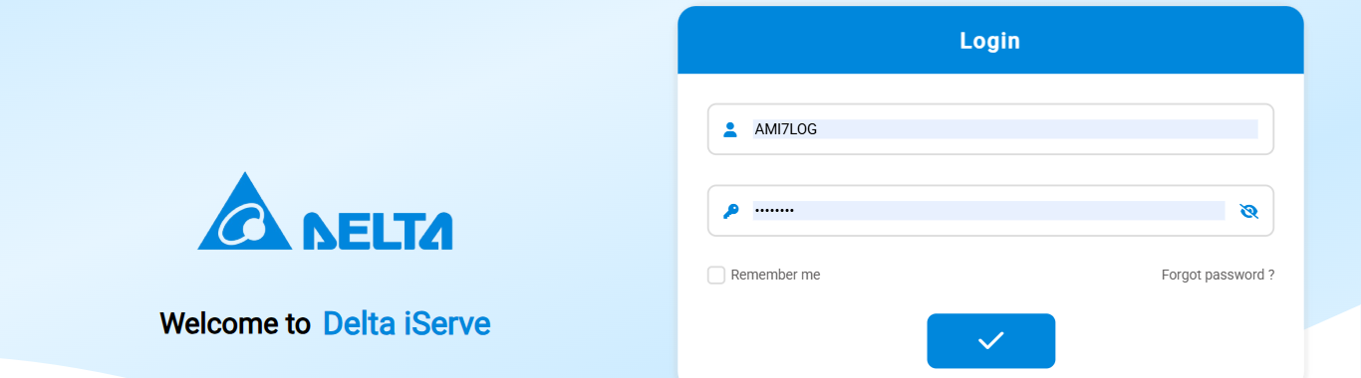2) Go to Inventory module, Inventory receipt

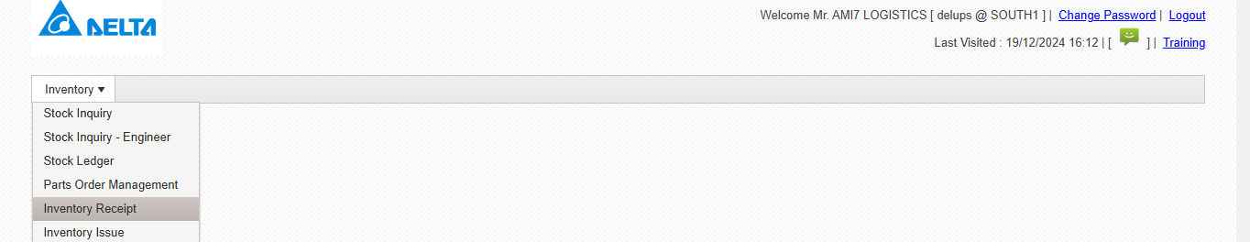

Confidential to Selfservit & Delta Electronics

Third Party warehouse to Mother Warehouse Spares return Process

3) See the receipt assigned to Mother warehouse logistics coordinator

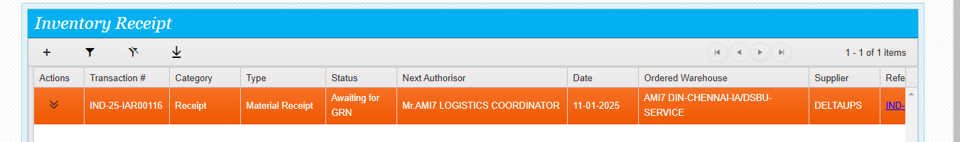4) Click on actions

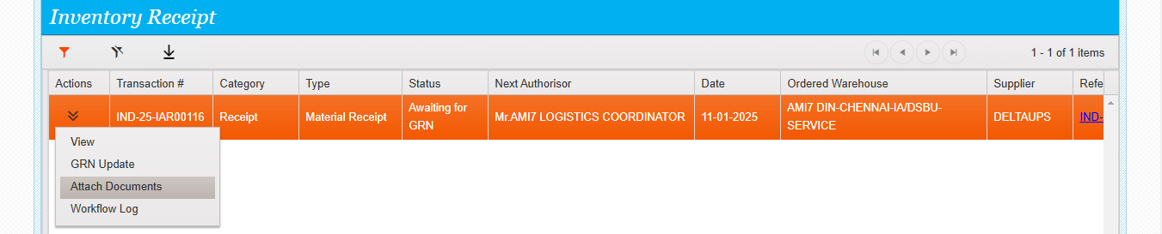5) Click GRN Update then the below screen will appear, enter the comments and submit.

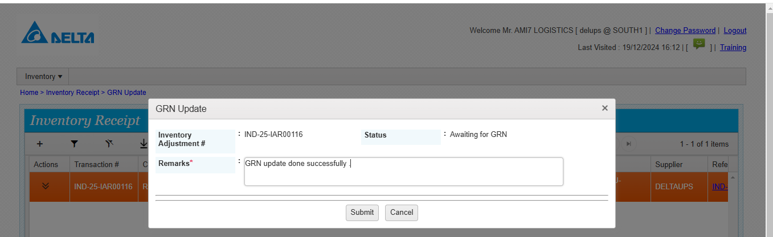

6) GRN update done successfully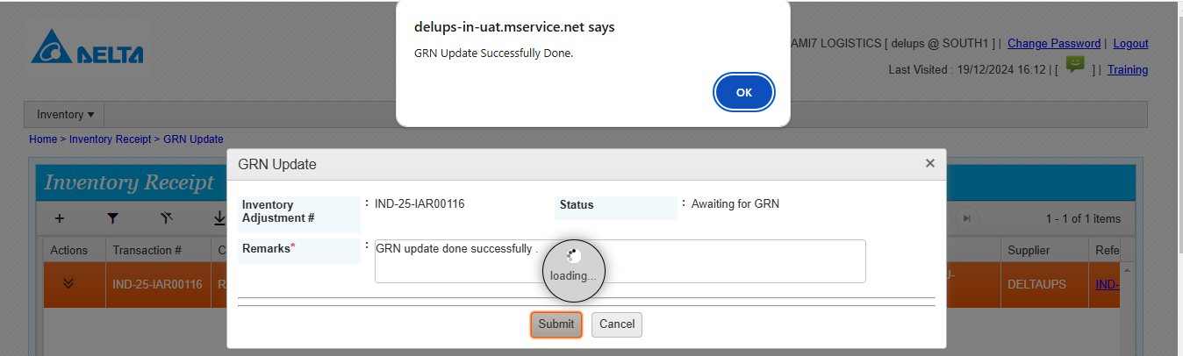Confidential to Selfservit & Delta Electronics

Third Party warehouse to Mother Warehouse Spares return Process

7) Parts inwarded into Mother Warehouse.

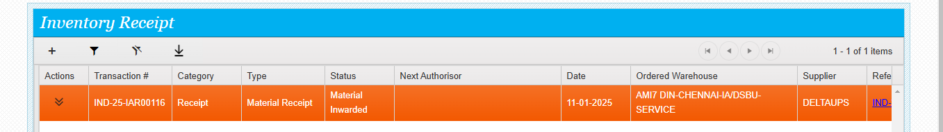8) Stock is showing in Mother Warehouse inventory

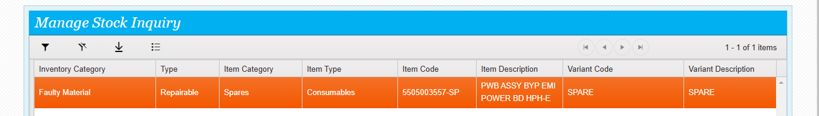Roles of Users

|  |  |  |
| --- | --- | --- |
| Sr.no | Users | Roles |
| 1 | Third party warehouse coordinator | Generate the return issue |
| 2 | Regional delta parts coordinator | DO the Return SO DO update |
| 3 | Third party warehouse coordinator | logistics update in Issue |
| 4 | Third party warehouse coordinator | Pick pack update in issue |
| 5 | Third party warehouse coordinator | despatch update in issue |
| 6 | Mother warehouse Logistics coordinator | GRN update in receipt |

Confidential to Selfservit & Delta Electronics